FIELDWORK ACTIVITY: VEGETATION PROFILE

Draw a vegetation profile somewhere on the school grounds. Choose a suitable location with an assortment of vegetation types.
You will need:
- Blank paper
- Lead pencil
- An assortment of coloured pencils
- A basic vegetation key (or you can identify the plants later on the internet).
10m
20m

Begin by drawing the line which will represent ground level. Ensure that if it is a slope or flat piece of land that your line accurately represents this. Draw in an approximate scale for height.

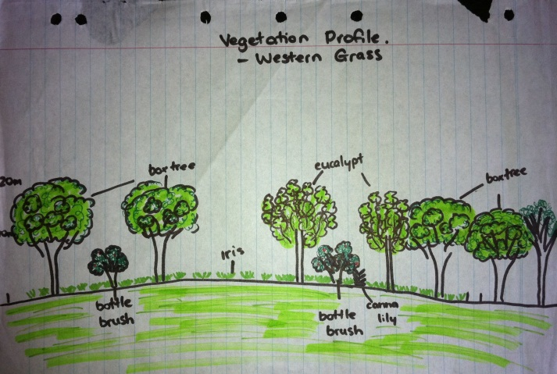
Draw the different types of plants that you see along the line. Ensure that you include smaller grasses as well as shrubs and trees. Label the plants with their common name. See if you can find out their botanical names.
10m
20m

Analysis: Try to determine why particular plants were found in different locations. It may be that the area was planted, but some plants may be in particular locations as a result of shade, soil, etc.

