BIOSPHERE POSTER ACTIVITY
Poster1:
Create a poster on the following theme:
A number of factors impact on where different types of vegetation are found. Create a series of diagrams or drawings which show these factors.
Example:
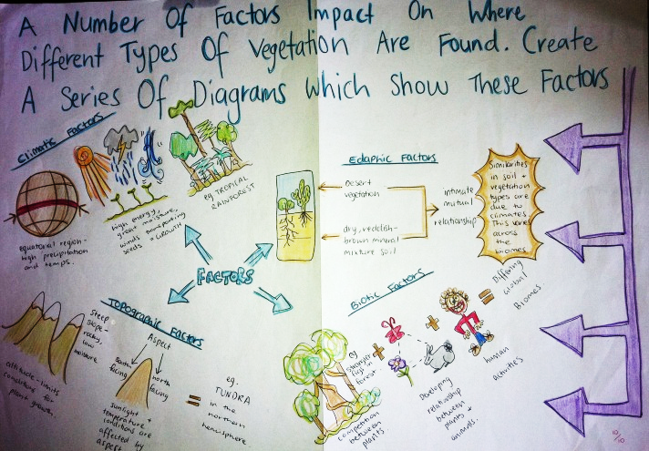

Created by Kimberley Watton
Poster 2:
Draw and label one aquatic food web and one terrestrial food web.
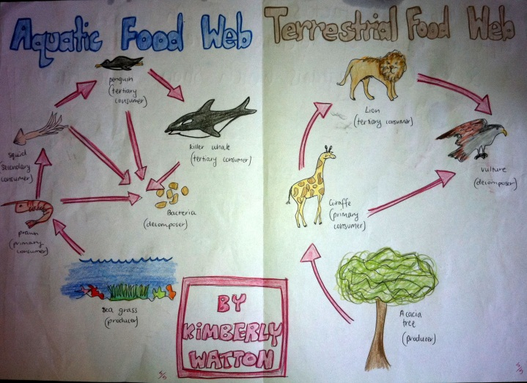

Created by Kimberley Watton

