Mekong River – Problem-based activity

The aim of this activity will be to identify a range of environmental problems affecting the Mekong River, and to explore possible solutions to some of these problems.

Overview

Lesson 1
Begin reading through the booklet of readings or complete internet research about the Mekong River. Readings and research should all relate to issues impacting on the Mekong region. Summarise the articles in the table provided.

Lesson 2
Continue reading and summarizing the articles.
Pair work - Determine one underlying issue affecting the Mekong Region.

Lesson 3
Create a flow chart which explores how your problem impacts on the biophysical environment.
Individual work - Write a summary of how the Mekong Region is sensitive to change.

Lesson 4
In pairs, suggest a range of solutions or management strategies to address your underlying problem.
Design a management strategy that can be applied across countries, up and downstream to address the issues in the Mekong Region.
Identify a range of professionals that you will need to employ to put your management plans into place.

Lesson 5
Mekong overview and presentation of management plans

Outcomes, content and skills:
- The sensitivity of the biophysical environment to change
- Relevance to particular vocations
- Planning a fieldwork activity
- Analysing field data
- Constructing and interpreting flow charts describing the key biophysical processes operating in a given area
- The importance of understanding key biophysical processes for effective management

Lesson 1

Overview: Begin reading through the booklet of readings or conduct internet research. The readings all relate to issues impacting on the Mekong region. Summarise the articles in the table provided.

Article number | Reading title | Environmental issues outlined in the article
1
2
3
4
5
6
7
8
9
10
11
12
13
14
15
16
17
18
19
20

Label the location of the issues you have read about on the map below on the next page. Place a number on the map which relates to the number of the relevant article.

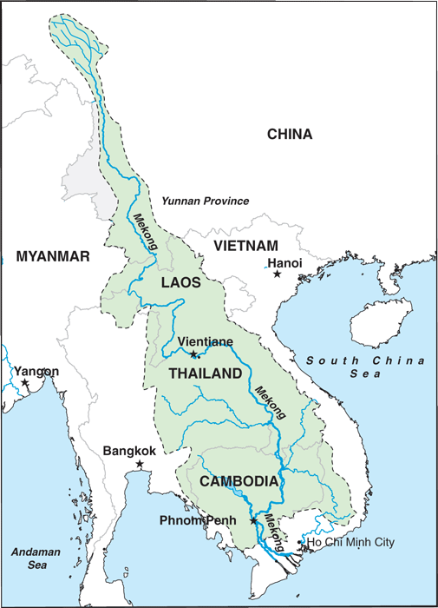
Map from http://www.schillerinstitute.org/economy/phys_econ/2012/seawapa.html

Lesson 2

Overview: Continue reading and summarising the articles.
Pair work - Determine one underlying issue affecting the Mekong Region.

In the previous lesson you identified a range of environmental issues affecting the Mekong Region. Now you need to come up with one single problem that encompasses as many of these issues as possible.

The underlying environmental issue affecting the Mekong Region is:

………………………………………………………………………………………………………………………………………………………………….………
………………………………………………………………………………………………………………………………………………………………………….
…………………………………………………………………………………………………………………………………………………………………………

Lesson 3

Overview: Create a flow chart which explores how your problem impacts on the biophysical environment.
Individual work - Write a summary of how the Mekong Region is sensitive to change.

Now that you’ve decided on the main environmental issue affecting the area, you need to consider the flow-on effects of the issue. Create a flow chart to represent this information. The flow chart has been started for you, but you will need to add on many more sections to create your flow chart.

Summary: Explain how the biophysical environment of the Mekong River is sensitive the change.

……………………………………………………………………………………………………………………………………………………………………………………………………………………………………………………………………………………………………………………….……………………………
…………………………………………………………………………………………………………………………………………………………………………………………………………………………………………………………………………………………………………………………………………………….
…………………………………………………………………………………………………………………………………………………………………………
……………………………………………………………………………………………………………………………………………………………………………………………………………………………………………………………………………………………………………………….……………………………
…………………………………………………………………………………………………………………………………………………………………………………………………………………………………………………………………………………………………………………………………………………….
…………………………………………………………………………………………………………………………………………………………………………
……………………………………………………………………………………………………………………………………………………………………………………………………………………………………………………………………………………………………………………….……………………………
…………………………………………………………………………………………………………………………………………………………………………………………………………………………………………………………………………………………………………………………………………………….
…………………………………………………………………………………………………………………………………………………………………………
……………………………………………………………………………………………………………………………………………………………………………………………………………………………………………………………………………………………………………………….……………………………
…………………………………………………………………………………………………………………………………………………………………………………………………………………………………………………………………………………………………………………………………………………….
…………………………………………………………………………………………………………………………………………………………………………
……………………………………………………………………………………………………………………………………………………………………………………………………………………………………………………………………………………………………………………….……………………………
…………………………………………………………………………………………………………………………………………………………………………………………………………………………………………………………………………………………………………………………………………………….
…………………………………………………………………………………………………………………………………………………………………………
……………………………………………………………………………………………………………………………………………………………………………………………………………………………………………………………………………………………………………………….……………………………
…………………………………………………………………………………………………………………………………………………………………………………………………………………………………………………………………………………………………………………………………………………….
…………………………………………………………………………………………………………………………………………………………………………
……………………………………………………………………………………………………………………………………………………………………………………………………………………………………………………………………………………………………………………….……………………………
…………………………………………………………………………………………………………………………………………………………………………………………………………………………………………………………………………………………………………………………………………………….
…………………………………………………………………………………………………………………………………………………………………………
……………………………………………………………………………………………………………………………………………………………………………………………………………………………………………………………………………………………………………………….……………………………
…………………………………………………………………………………………………………………………………………………………………………………………………………………………………………………………………………………………………………………………………………………….
…………………………………………………………………………………………………………………………………………………………………………
……………………………………………………………………………………………………………………………………………………………………………………………………………………………………………………………………………………………………………………….……………………………
…………………………………………………………………………………………………………………………………………………………………………………………………………………………………………………………………………………………………………………………………………………….
…………………………………………………………………………………………………………………………………………………………………………
……………………………………………………………………………………………………………………………………………………………………………………………………………………………………………………………………………………………………………………….……………………………
…………………………………………………………………………………………………………………………………………………………………………………………………………………………………………………………………………………………………………………………………………………….
…………………………………………………………………………………………………………………………………………………………………………
……………………………………………………………………………………………………………………………………………………………………………………………………………………………………………………………………………………………………………………….……………………………
…………………………………………………………………………………………………………………………………………………………………………………………………………………………………………………………………………………………………………………………………………………….
…………………………………………………………………………………………………………………………………………………………………………
……………………………………………………………………………………………………………………………………………………………………………………………………………………………………………………………………………………………………………………….……………………………
…………………………………………………………………………………………………………………………………………………………………………………………………………………………………………………………………………………………………………………………………………………….
…………………………………………………………………………………………………………………………………………………………………………
……………………………………………………………………………………………………………………………………………………………………………………………………………………………………………………………………………………………………………………….……………………………
…………………………………………………………………………………………………………………………………………………………………………………………………………………………………………………………………………………………………………………………………………………….
…………………………………………………………………………………………………………………………………………………………………………

Lesson 4

Overview: In pairs, suggest a range of solutions or management strategies to address your underlying problem. Design a management strategy that can be applied across countries, up and downstream to address the issues in the Mekong Region. Identify a range of professionals that you will need to employ to put your management plans into place.

The main environmental issue that I identified is….

Local solutions
Regional solutions
National solutions
Bi-lateral and multi-lateral solutions (solutions that involve 2 or more countries)

Design your management strategy: Write a management strategy to be implemented in the Mekong region. Use the table below as a planning sheet. Your management plan should be typed, stapled and printed to be handed in at the next lesson.

Write a brief summary of the environmental issues affecting the Mekong region at the large-scale (approx. 100 words).
Write brief summary of the need for different countries to work together to address the problems of the Mekong River. Why do they need to work together? What are the benefits of them working together? (approx. 100 words).
Write a brief summary of the large-scale strategies to solve the environmental issues (approx. 100 words)
Write a brief summary of the environmental issues affecting the Mekong region at the regional level (approx. 100 words).
Write a brief summary of the regional-scale strategies to solve the environmental issues (approx. 100 words)
Write a brief summary of the environmental issues affecting the Mekong region at the local level (approx. 100 words).
Write a brief summary of the local-scale strategies to solve the environmental issues (approx. 100 words)
Identify fieldwork techniques that you could use to monitor the effectiveness of the management strategies.
Identify a range of professionals that you will need to employ to put your management plans into place.

